Creating a Clustered Bar Chart using SPSS Statistics

## Example

A researcher was interested in whether an individual's interest in politics was influenced by their level of education and their gender. The researcher recruited a random sample of participants and asked them about their interest in politics, which they scored from 0 - 100 with higher scores meaning a greater interest. The researcher then divided the participants by gender (Male/Female), and then again by level of education (School/College/University).

Therefore, the dependent variable was Interest in Politics (which we labelled "Int_Politics" in SPSS Statistics). The two independent variables were Gender (labelled "Int_Politics" in SPSS Statistics) and Educational Level (labelled "Edu_Level" in SPSS Statistics), where Gender consisted of two independent groups ("Male" and "Female"), and Educational Level three independent groups ("School", "College" and "University").

* Click **Graphs > Chart Builder...** on the top menu as shown below:

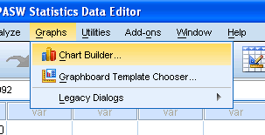

Published with written permission from SPSS Statistics, IBM Corporation.

* You will be presented with the following screen:

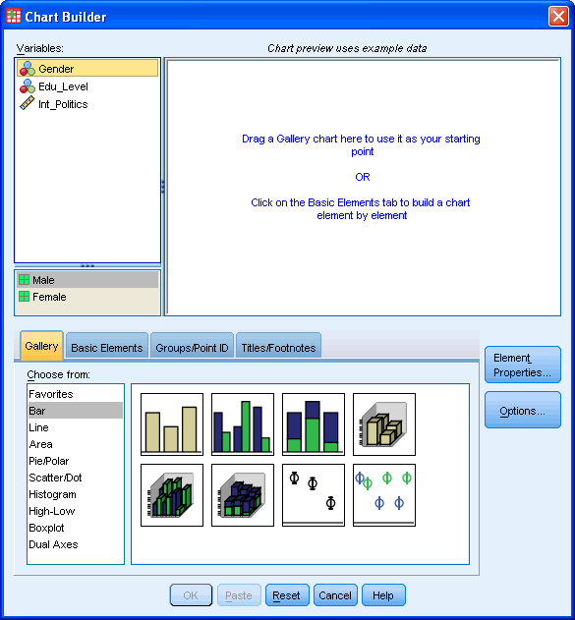

Published with written permission from SPSS Statistics, IBM Corporation.

* Under the Gallery Tab (SPSS Gallery Tab), select the **Bar** option and the **clustered bar chart** icon (top row, second from left). Drag-and-drop this icon into the **Chart Preview Area** (as shown below).

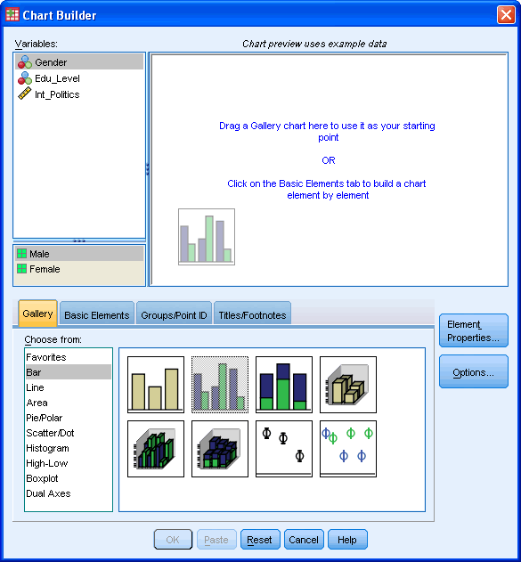

Published with written permission from SPSS Statistics, IBM Corporation.

* You will be presented with the following dialog boxes: **Chart Builder** and **Element Properties**. As you can see, the **Chart Preview Area** has been populated with a template of a clustered bar chart.

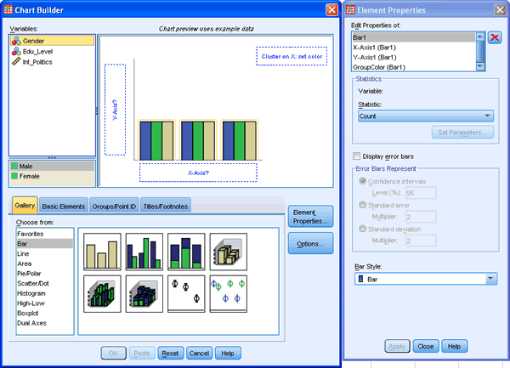

Published with written permission from SPSS Statistics, IBM Corporation.

Transfer the independent variable Edu_Level into the "**X-Axis?**" box, the other independent variable, Gender, into the "**Cluster on X: set color**" (top-right corner of the **Chart Preview Area**) and the dependent variable Int_Politics into the "**Y-Axis?**" box.

